10.NB-IoT vs LTE-M Throughput Simulation

Aim

To simulate and compare the throughput of NB-IoT and LTE-M based on their bandwidth and modulation schemes.

Software Required

MATLAB / Octave

Basic plotting functions only

Theory (Simple)

NB-IoT uses 180 kHz bandwidth and usually QPSK modulation.

LTE-M uses 1.4 MHz bandwidth and supports QPSK / 16QAM.

Throughput ≈ Bandwidth × log₂(M) × (1 – BER)

Higher bandwidth + higher modulation = higher throughput.

Procedure (Simple)

Define bandwidth for NB-IoT and LTE-M.

Choose modulations (NB-IoT = QPSK, LTE-M = QPSK & 16QAM).

Sweep SNR from –5 to 25 dB.

Compute BER using simple function.

Compute throughput.

Plot and compare both systems.

Pseudocode (Simple)

set BW_NB = 180 kHz
set BW_LTEM = 1.4 MHz
mod_NB = QPSK (M=4)
mod_LTEM = 16QAM (M=16)
for SNR = -5 to 25 dB
compute BER for each modulation
compute throughput = BW * log2(M) * (1-BER)
plot NB-IoT and LTE-M throughput vs SNR

Code
clear; clc; close all;

%% PARAMETERS
BW = [180e3, 1.4e6]; % Bandwidth: NB-IoT, LTE-M (Hz)
latency = [1, 0.1]; % Latency in seconds (NB-IoT, LTE-M)
SNR_dB = 0:5:30; % SNR range in dB
tech = {'NB-IoT','LTE-M'}; % Technology names

%% Throughput vs SNR
throughput = zeros(length(BW), length(SNR_dB));

for t = 1:length(BW)
for s = 1:length(SNR_dB)
snr_linear = 10^(SNR_dB(s)/10);
C = BW(t) * log2(1 + snr_linear); % Shannon capacity
throughput(t,s) = C * (1/latency(t)); % Adjust for latency
end
end

% Plot Throughput vs SNR
figure; hold on;
colors = {'b','r'};
for t = 1:length(BW)
plot(SNR_dB, throughput(t,:)/1e3, 'LineWidth',2,'Color',colors{t}); % kbps
text(SNR_dB(end)+0.5, throughput(t,end)/1e3, tech{t}, 'Color',colors{t}, ...
'FontWeight','bold','FontSize',10);
end
grid on;
xlabel('SNR (dB)');
ylabel('Throughput (kbps)');
title('NB-IoT vs LTE-M Throughput vs SNR');

%% Throughput vs Bandwidth at Fixed SNR
fixed_SNR_dB = 20; % Example SNR
throughput_bw = zeros(length(BW),1);

for t = 1:length(BW)
snr_linear = 10^(fixed_SNR_dB/10);
C = BW(t) * log2(1 + snr_linear);
throughput_bw(t) = C * (1/latency(t));
end

% Plot Throughput vs Bandwidth
figure;
bar(throughput_bw/1e3); % kbps
set(gca,'XTickLabel',tech,'FontWeight','bold');
ylabel('Throughput (kbps)');
title(['Throughput vs Bandwidth at SNR = ' num2str(fixed_SNR_dB) ' dB']);
grid on;

OUTPUT:

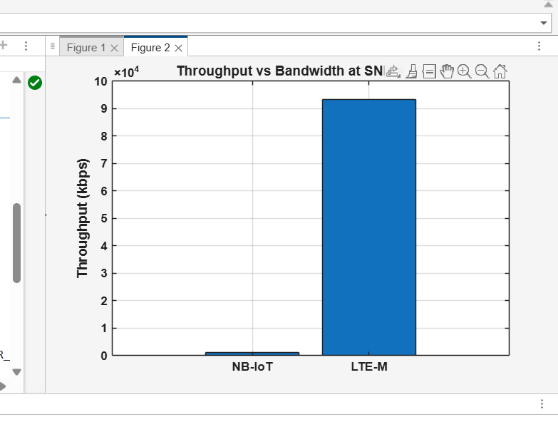

Result (Very Simple)
LTE-M provides much higher throughput than NB-IoT at all SNR levels because it uses larger bandwidth and higher-order modulation.

